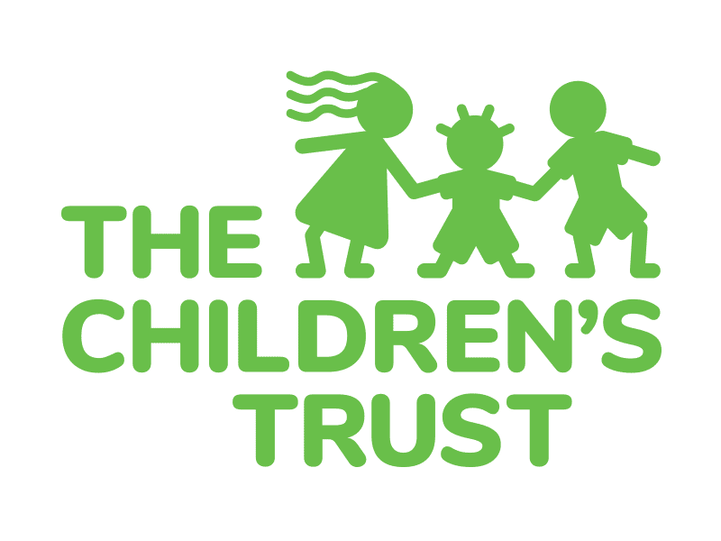

AUTHORIZATION FOR PHOTOGRAPHY/VIDEO

I, ________________________________________________, the parent or guardian of _________________________________________, hereby authorize and give consent to the staff of The Children’s Trust of Miami-Dade County and/or its funded service providers as follows:

I hereby:

❒ consent and authorize OR  do not consent and authorize

the staff of The Children’s Trust of Miami-Dade County and/or its funded service providers to take/use still photographs, digital photographs, motion pictures, television transmissions and/or videotaped recordings (hereinafter “Recordings”) of me, my children or my wards for educational, research, documentary and public relations purposes.

_______________________________________ _______________________________________
Signature of Parent or Guardian Signature of Witness

_______________________________________ _______________________________________
Date Date

Any such Recordings may reveal your identity through the image itself without any compensation to you, your children or wards.

Any and all Recordings taken of you, your children or wards shall be the sole property of The Children’s Trust and its funded service providers.

With regard to the use of any Recordings taken of you, your children or wards, you hereby waive any and all present and future claims you may have against The Children’s Trust of Miami-Dade County and its staff, funded service providers, employees, agents, affiliates and board members.

3150 SW 3rd Avenue, 8th Floor ● Miami, FL 33129
305.571.5700 ● Fax: 305.857.9592
www.thechildrenstrust.org

