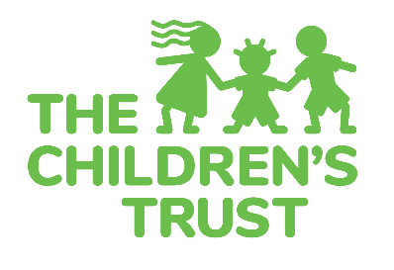
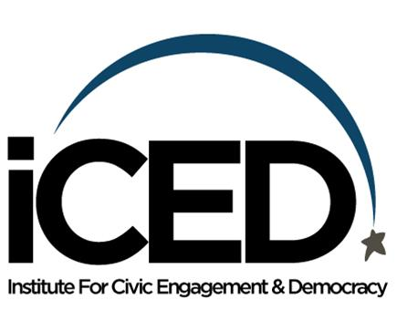

YAC Civic Activism Scorecard

How to Use the Civic Activism Scorecard:
YAC participants who complete 5 civic actions on this scorecard by between September and April can earn 5 additional community service hours and the YAC Activism Award.
Civic Action Item Categories are listed below:

1. | Participate in the challenge hosted by Xavier and Izzy to promote the census. | Post a 15 to 60 second video on social media tagging xavier.g and izzy.garreton, and share your experience at the next meeting.
2. | Sandy Hook Promise Promise 2 Be Kind Challenge: Student performs 17 acts of random kindness or send 17 kind notes. Share your experience on social media, in discussion or in writing at the next meeting. | Share your experience on social media, in discussion or in writing at the next meeting.
3. | Sign at least 5 petitions relating to social issues and causes you support. (e.g., www.change.org) | Share about 1 of the petitions on social media or in writing or in discussion at the next meeting.
4. | Read two civic articles on topics of democracy, community building, diversity, leadership, social change | Share about 1 of the articles on social media or in writing or in discussion at the next meeting.
5. | Host or participate in an environmental clean up of your neighborhood, local beach or park, while abiding by safety precautions. | Document in some way to share at the next meeting - social media, photograph, art piece, poem, reflection writing.
6. | Take a virtual tour of any national park in Florida. | Write a short paragraph describing what you learned or share it at the next meeting.
7. | Encourage your school community to virtually celebrate each other’s uniqueness without judgment or fear. Students can wear a costume, pajamas or other items that are unique to them. | Take a photo, write a reflection, sketch what you saw, post on social media to share at the next meeting.
8. | Find the sample ballot for upcoming November election. | Print it out from the Boards of Elections website to share. http://www.miamidade.gov/elections/sampleballots.asp-
9. | Participate in an online or in person campaign for a cause that is fair and just for your community (with positive signage while abiding by safety precautions). | Take a photo, write a reflection, sketch what you saw, post on social media to share at the next meeting.
10.  Dec. | Sandy Hook Promise: Students take selfies of themselves and club members or fellow students holding a sheet of paper saying what they "Promise 2." | Show selfies.
11. | Attend virtually or in person a municipal, School Board, county or other local or regional government meeting. | Take photos, sketch or write about the topics discussed, the decision-making process and different perspectives.
12. | View one civic documentary on a topic such as democracy, community building, diversity, leadership, social change, food, social justice, etc.) | Share what you learned with the group at the next meeting.
13. | Take a practice Citizenship Exam at https://my.uscis.gov/prep/test/civics | Share a screen shot of your score or speak to the group about your experience.
14. | Subscribe electronically (e.g., via an app or the email) to a reputable local or state news service (Social media is not eligible.) Examples include: The Miami Herald, The Sun Sentinel, The New Tropic, The Miami Times. | Screen shot the image of the subscription or newsletter in your inbox to share.
15. | Email or write your elected official or the editor of a newspaper/ magazine on a topic of importance or concern. Identify your state representative:  https://www.myfloridahouse.gov/Sections/Representatives/myrepresentative.aspx | Provide a copy of your letter at the next meeting for the group to see your courageous work.
16. | Have a political dialogue with someone through a virtual platform with whom you disagree on a social or political issue. (*dialogue= seeking to understand the other person's point of view, and helping him/ her understand yours, done with respect, civility, and a desire to a find common ground) | Write or share the difference between your opinions and how you tried to understand the other's point of view and what lessons you learned from the experience.
17. | Look up the state representatives for your zip code and call or go into the office to introduce yourself and talk about your membership in the Youth Advisory Committee. Tell him/ her about your upcoming trip to Tallahassee and ask if you could possibly with him/ her. | Share your experience with the group verbally or in writing. What are the steps you took and how were you received? Did they know about The Children’s Trust YAC?
18. | Sandy Hook Promise: Say “hello” to 17 people that you do not know. | Share your experience. Who were some of the people you said hello to, where were you, how were you received.
19. | Look up the state representatives for your zip code and call or go into the office to introduce yourself and talk about your membership in the Youth Advisory Committee. Tell him/ her about your upcoming trip to Tallahassee in March and whether you could meet with him/ her. | Share your experience with the group verbally or in writing. What are the steps you took and how were you received? Did they know about The Children’s Trust YAC?
20. | Fundraise for a nonprofit that you have researched and believe in. | Present on the nonprofit you fundraised for and explain why you chose that organization.
21. | Create a piece of art that communicates a social issue. | Bring in the art piece to the next meeting.
22. | Visit a farmer's market to buy local products and strike up a conversation with the seller. | Share photographs, writing or verbal explanation the farmer’s market location, products, and individual seller you spoke to.
23. | Create your own challenge.

Thank you to Miami Dade College iCED office http://www.mdc.edu/main/iced/

