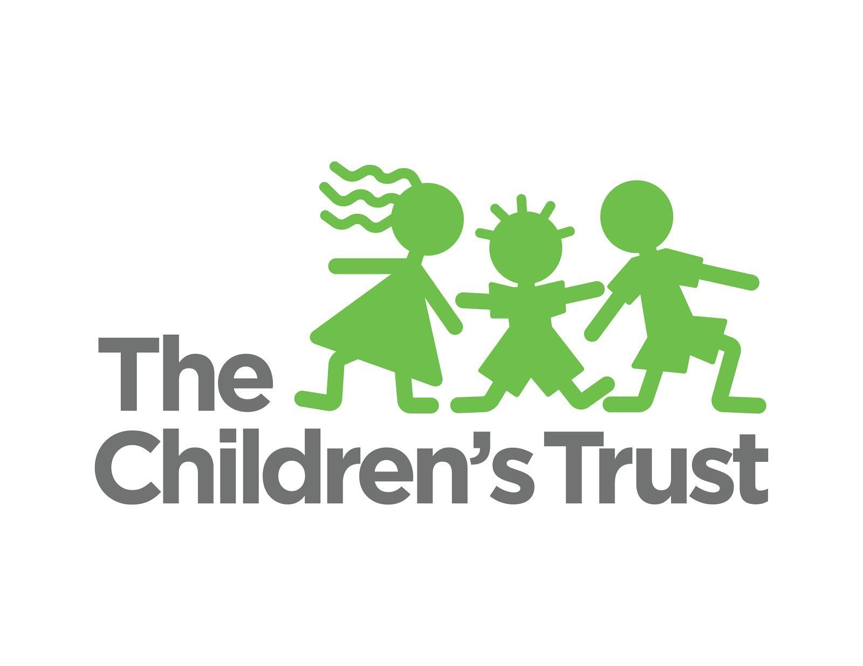

Community Outreach & Broadcast/Print Publicity Report

February 4, 2018 – February 27, 2018

Board Meeting: Monday, March 12, 2018

This report (with live links) may be downloaded from the March 12, 2018, board meeting page on our
community calendar.

The Children’s Trust in the Community

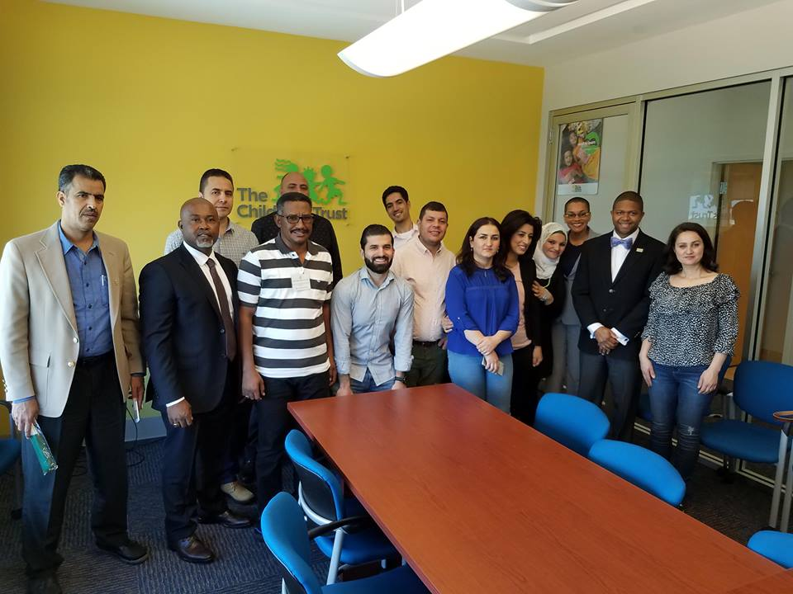
March 1, Miami

Hosting participants of the U.S. Department of State International Leadership Program.

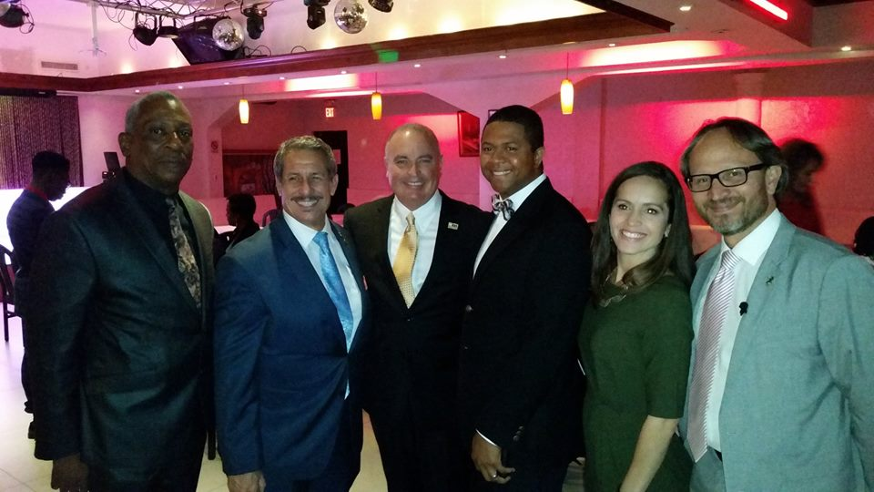
February 9, Miami

At the inaugural MagicWaste Youth Foundation’s Valentine’s luncheon.

PUBLICITY

March 4
The Islander News
Reach: N/A
The (Dr.) Joy of music: Local educator reaches kids through the power of song
Feature story about local music educator Dr. Joy Galliford; Trust mentioned as past collaborator; Trust funds program through Miami-Dade Cultural Affairs
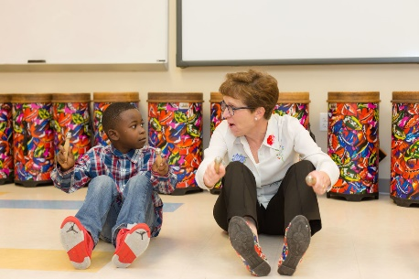

February 27
Miami Herald
Reach: 5,000,000
Students honored at 2018 NASCAR Drive for Diversity Awards
Young Talent Big Dreams 2018 auditions highlighted; Trust mentioned as an initiative partner

February 25
WPLG Local 10 News
Local 10 News Sunday Morning (two mentions: 5:30 and 7 a.m.)
Community calendar mention of Young Talent Big Dreams auditions

February 12
The Miami Times
We're celebrating our publisher emeritus' birthday by giving you a free gift
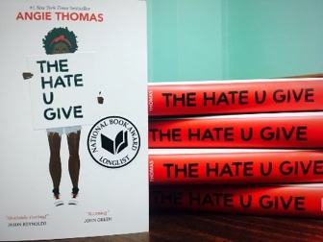
Trust credited as being behind a special book giveaway

February 12
Miami Herald
Reach: 5,000,000
A-Rod, Maurice Ferre Jr. among 2018 judges
Trust Chief Program Officer Stephanie Sylvestre among 2018 judges
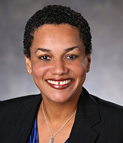

February 20
Miami Herald
Reach: 5,000,000

Use playtime to boost your children’s brainpower
Feature byline: Trust staffer Kathleen Dexter
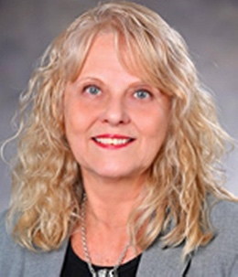

February 8
Miami Herald
Reach: 5,000,000
Teens suffer abusive romantic relationships, too
Feature byline: Trust staffer Tameeka Grant

