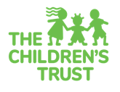
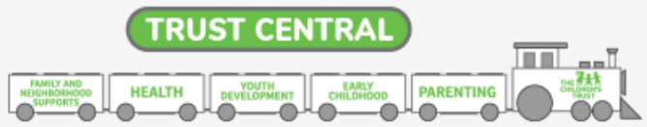

PARENT, GUARDIAN, OR PRIMARY CAREGIVER INFORMATION FORM

Participant's Last Name First Middle Name
Date of Birth (MM/DD/YYYY) ) / / Gender Female Male
Street Address City ZIP Code
Primary Phone Number ( ) - Is this a cell/mobile phone? Yes No
Email Address
Please note that The Children’s Trust may contact you vial postal mail, email and/or text to ask about your satisfaction with services, and to make you aware of other Trust-funded programs, initiatives and events that may interest you.

Are you a parent, guardian or primary caregiver? Yes No
How many children are in your care?

How many of the children in your care have a disability or condition expected to last for a year or more that makes it harder for them to do things that other children of the same age can do?
What is the highest level of education you’ve completed?
Grade ________ HS Diploma/GED Some College Associate Degree Bachelor’s Degree Graduate Degree
Are you proficient in English? Yes No
Other language(s) spoken in your home Spanish Haitian Creole Other: _____________ None
Ethnicity Hispanic Haitian Other, please specify:
Race (select one) American Indian or Alaskan Asian Black or African American
Pacific Islander White Multiracial Other

If you are interested in other services funded by The Children’s Trust, please call 211 or visit www.thechildrenstrust.org.
For special needs resources for your child/youth, visit www.advocacynetwork.org or
www.thechildrenstrust.org/content/children-disabilities.

I give my permission for this information to be submitted to The Children's Trust for program quality and evaluation purposes. The Children’s Trust provides funding for the program and follows strict data privacy protections for the information collected.

PARTICIPANT SIGNATURE DATE

FOR STAFF USE ONLY (MUST BE COMPLETED)
ORGANIZATION SITE
POPULATION MEMBERSHIP (check all that apply): Dep Syst Delin Syst

